Assignment 3
Module: Fundamentals of Data Science
Student Name: Sizone Giri

Program 1:

Description of the Program:

A program to count the number of lines, words, and characters in a text file.

Source Code:

# Open the file in read mode
file = open("program1.txt", 'r')
# Calculate the total number of lines in the file
total_lines = len(file.readlines())
print('Total number of lines in the file:', total_lines)

# Reset the file pointer to the beginning of the file
file.seek(0)
# Initialize a counter for the total number of words
total_word_count = 0
# Read the entire file content into a string
file_content = file.read()
# Split the content into individual words
word_list = file_content.split()
# Iterate over each word in the list
for word in word_list:
total_word_count += 1
print(f"Total number of words in the file: {total_word_count}")

# Initialize a counter for the total number of characters
total_char_count = 0
# Iterate over each character in the file content
for char in file_content:
total_char_count += 1
print(f"Total number of characters in the file: {total_char_count}")
file.close()

Output Screenshot:
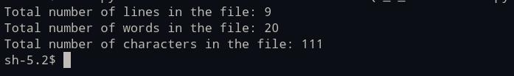

Program 2:

Description of the Program:
A program to copy the contents of one file to another.
Source Code:

# A function to copy the contents of one file to another
def copy_file():
# Prompting the user to enter the name of the source file
source = input("Enter the name of source file: ")

# Prompting the user to enter the name of the destination file
destination = input("Enter the name of destination file: ")

try:
# Opening the source file in read mode and store its content
with open(source, 'r') as source_file:
content = source_file.read()
# Printing the content of the source file
print(content)

# Opening the destination file in write mode and write the content
with open(destination, 'w') as destination_file:
destination_file.write(content)
# Printing a success message
print("You have copied the content of the file successfully")

except FileNotFoundError:
# Handling the case when the source file does not exist
print("The file does not exist")

except Exception as e:
# Handling any other exceptions and print the error message
print(f"An error occurred: {e}")

# A loop to allow the user to copy multiple files
while True:
# Calling the copy_file function
copy_file()
# Prompting the user to enter whether they want to copy another file
cont = input("Do you want to copy another file? (yes/no): ")
# If the user enters anything other than "yes", breaking the loop
if cont.lower() != "yes":
break

Output Sceenshot:
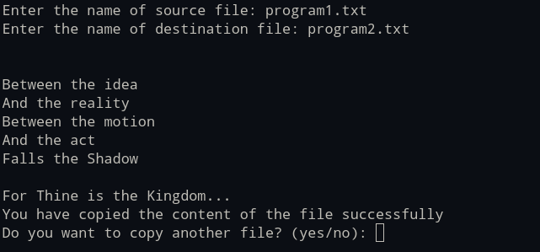

Program 3:

Description of the Program:
A program to find and replace a specific word in a file with another word.

Source Code:
# Getting the user input
file_name = input('Enter the name of your file: ')
old_word = input('Enter the word that should be replaced: ')
new_word = input('Enter the new word: ')

# Checking if the file exists
try:
with open(file_name, 'r') as file:
content = file.read()

# Checkinf if the file is not empty
if not content:
print("The file is empty.")
exit()

# Checking if the old word is found in the file
if old_word not in content:
print("The word '{}' is not found in the file.".format(old_word))
exit()

# Checking if the new word is different from the old word
if old_word == new_word:
print("The new word is the same as the old word.")
exit()

# Replacing the old word with the new word
replaced_content = content.replace(old_word, new_word)

# Writing the modified content back to the file
with open(file_name, 'w') as file:
file.write(replaced_content)
print("The word replaced successfully.")

except FileNotFoundError:
print("The file does not exist.")

except Exception as e:
print("An error occurred: {}".format(e))

Output Screenshot(s):


Program 4:

Description of the Program:
A program to read a CSV file and display its contents in a tabular format

Source Code:
import csv

user_input = input('Please enter the CSV file name: ')

try:
with open(user_input,'r')as data_file: #opens the file for reading
data_reader = csv.reader(data_file) #reads the file content line by line
print ("\nCSV File Contents:")

for data_line in data_reader:
#formatting for better readability
print('\t'.join(data_line)) #lines are printed separated by tabs

except FileNotFoundError:
print("File not found in the system")

except Exception as error_message:
print (f"An error occurred: {error_message}")

Output Screenshot:


Program 5:

Description of the Program:
A program that counts the occurrence of each word in a file

Source Code:

document_title = input("Please enter the document name: ")

try:
# Accessing the document in text mode
with open(document_title, "r") as document: # Opens the document in text mode
text_data = document.read()

text_data = text_data.lower() # Transforms the text to lowercase
phrases = text_data.split() # Divides the text into phrases
phrase_frequency = {} #empty dictionary

# Examining each phrase
for phrase in phrases:
if phrase not in phrase_frequency: # Checks if the phrase is not already in the dictionary
phrase_frequency[phrase] = 1 # Adds the phrase with an initial frequency of 1
else:
phrase_frequency[phrase] += 1 # Increments the frequency for repeated phrases

# Display the phrase frequencies
print("\nPhrases and their frequency:")
# Each phrase and its frequency iterates through the dictionary
for phrase, frequency in phrase_frequency.items(): #.items() returns key-value pairs as tuples
document_phrase = phrase
frequency_count = frequency
print(f"{document_phrase}: {frequency_count}")

except FileNotFoundError:
print("The document was not found.")
except Exception as e:
print(f"The issue is {e}")

Output Screenshot:
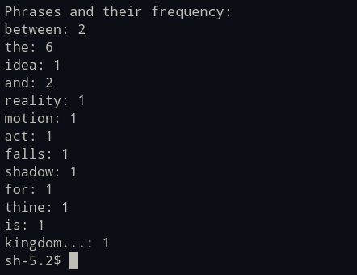

Program 6:

Description of the Program:
A program with a class Student with the attributes such as id, name, address, admission year, level, section. The program will instantiate the object of class to take input for all the attributes and display the output.

Source Code:

class Student:
def __init__(self):
#initializing the attributes of the object
self.student_id= input("Enter student ID: ")
self.student_name= input("Enter the name of student: ")
self.student_address=input("Enter the address of student: ")
self.student_admission_year=input("Enter the admission year of student: ")
self.student_level=input("Enter the level of student: ")
self.student_section=input("Enter the section of student: ")

def display(self):
# Displays the student details
print("\n ---Student details--- \n")
print(f" ID:, {self.student_id}")
print(f" Name:, {self.student_name}")
print(f" Address:, {self.student_address}")
print(f" Admission Year: {self.student_admission_year}")
print(f" Level: {self.student_level}")
print(f" Section:, {self.student_section}")

student1= Student()# Creating an instance of student class

student1.display()

Output Screenshot:
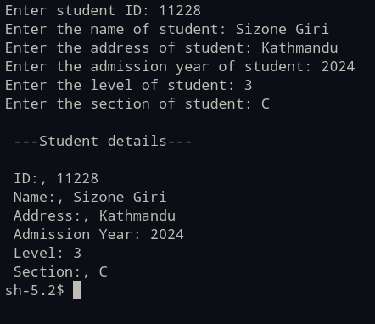

Program 7:

Description of the Program:
A program to implement a class called employee with attributes such as
empid, name, address, contact_number, spouse name, number_of_child, salary and do the following:
Instantiate the class to input the values for multiple employees and write it in a file “employees.csv”.
Allow the user of your program to see the list of employees and their details as well.
Try to use the concept of try/except too in the program.

Source Code:

import csv

class Employee:
# initializing employee attributes
def __init__(self, empid, name, address, contact_number, spouse_name, child_count, salary):
self.empid = empid
self.name = name
self.address = address
self.contact_number = contact_number
self.spouse_name = spouse_name
self.child_count = child_count
self.salary = salary

def collect_staff_info(): # returns the instance of employee
try:
staff_id = int(input("Enter the Staff ID: "))
staff_name = input("Enter the Staff Name: ")
staff_address = input("Enter the Staff Address: ")
staff_contact = int(input("Enter the Staff Contact Number: "))
staff_spouse = input("Enter the Staff Spouse Name: ")
staff_children = int(input("Enter the Number of Staff Children: "))
staff_salary = float(input("Enter the Staff Salary: "))
return Employee(staff_id, staff_name, staff_address, staff_contact, staff_spouse, staff_children, staff_salary)
except Exception as e:
print(f"An error occurred: {e}")
return None

def export_staff_to_csv(staff_members, filename="staff_members.csv"): # writes the list of staff to csv file
try:
with open(filename, 'w', newline='') as file: # open file in write mode
writer = csv.writer(file)
# writing the header row to the file
writer.writerow(["Staff ID", "Staff Name", "Staff Address", "Staff Contact", "Staff Spouse", "Number of Staff Children", "Staff Salary"])
for staff in staff_members:
writer.writerow([staff.empid, staff.name, staff.address, staff.contact_number, staff.spouse_name, staff.child_count, staff.salary])
print("Staff details exported successfully.")
except Exception as e:
print(f"A problem occurred: {e}")

def display_staff_members(staff_members):
if not staff_members:
print("There is no staff data to display.")
else:
for staff in staff_members: # iterate over the list and displays the details
print(f"Staff ID: {staff.empid}, Name: {staff.name}, Address: {staff.address}, "
f"Contact: {staff.contact_number}, Spouse: {staff.spouse_name}, Children: {staff.child_count}, Salary: {staff.salary}")

def main_program():
staff_members = [] # initializing empty list
while True:
print("\n--- Staff Details ---\n")
print("1. Add a staff member")
print("2. Display Staff Details")
print("3. Export details to the CSV")
print("4. Exit")

choice = int(input("Enter your choice: "))

if choice == 1:
staff = collect_staff_info()
if staff: # adds staff if there's no error
staff_members.append(staff)
elif choice == 2:
display_staff_members(staff_members)
elif choice == 3:
export_staff_to_csv(staff_members)
elif choice == 4:
print("You are exiting the program...")
break
else:
print("Invalid choice. Please choose a valid number (1-4).")

if __name__ == '__main__':
main_program() # main function is executed when all the data are valid

Output Screenshot(s):
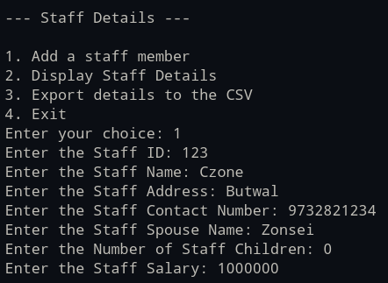

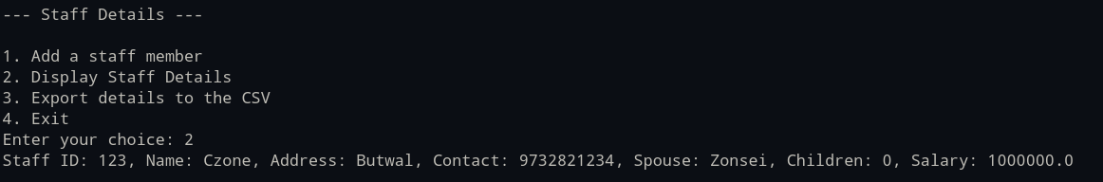




Program 8:

Description of the Program:
A program to implement a basic library book management with the functionalities such as
to issue the book, return the book and search the book.
The program will have:
# Use the concept of OOP to create the necessary classes on your own and implement the concept of other OOP features.
# For the storage of book details, use the file handling along with the exception handling.

Source Code:

# Class to Represent Individual Book Objects

class Publication:
def __init__(self, catalog_number, publication_title, publication_author):
self.catalog_number = catalog_number # Unique Identifier for Publications
self.publication_title = publication_title # Title of the Publication
self.publication_author = publication_author # Author of the Publication

class Catalog:
def __init__(self):
self.publications = [] # Empty List to Store Publication Objects
self.load_publication_data() # Load Publication Data from File

def load_publication_data(self):
try:
with open("publications.txt", "r") as file:
for line in file:
catalog_number, publication_title, publication_author = line.strip().split(",") # Split Line into Catalog Number, Title, and Author
self.publications.append(Publication(catalog_number, publication_title, publication_author)) # Add Publication to List
except FileNotFoundError:
print("The file does not exist.")
except Exception as e:
print(f"An error occurred: {e}")

def save_publication_data(self):
with open("publications.txt", "w+") as file:
for publication in self.publications:
file.write(f"{publication.catalog_number}, {publication.publication_title}, {publication.publication_author}\n")

def display_publications(self):
try:
if self.publications:
print("Publications in the Catalog")

for publication in self.publications:
print(f"Catalog Number: {publication.catalog_number}, Title: {publication.publication_title}, Author: {publication.publication_author}")
except Exception:
print("No publications available in the catalog.")

def check_out_publication(self, catalog_number):
try:
for publication in self.publications:
if publication.catalog_number == catalog_number:
self.publications.remove(publication)
print(f"The publication {publication.publication_title} ({publication.catalog_number}) has been checked out.")
self.save_publication_data()
return
except Exception:
print("Publication not found.")

def return_publication(self, catalog_number, publication_title, publication_author):
self.publications.append(Publication(catalog_number, publication_title, publication_author))
print(f"The publication {publication_title} ({catalog_number}) has been returned.")
self.save_publication_data()

def search_publication(self, publication_title):
for publication in self.publications:
if publication.publication_title.lower() in publication.publication_title.lower():
print(f"{publication.publication_title}, {publication.catalog_number} has been found.")
return
print("Publication not found.")

def main():
catalog = Catalog()

while True:
print("\n--- Catalog Menu: ---\n")
print("1. Display Publications")
print("2. Check Out Publication")
print("3. Return Publication")
print("4. Search Publication")
print("5. Exit")
choice = input("Enter your choice: ")

if choice == "1":
catalog.display_publications()
elif choice == "2":
catalog_number = input("Enter the Catalog Number to check out: ")
catalog.check_out_publication(catalog_number)
elif choice == "3":
catalog_number = input("Enter the Catalog Number to return: ")
publication_title = input("Enter the Title of the publication: ")
publication_author = input("Enter the Author of the publication: ")
catalog.return_publication(catalog_number, publication_title, publication_author)
elif choice == "4":
publication_title = input("Enter the Title of the publication to search: ")
catalog.search_publication(publication_title)
elif choice == "5":
print("Exiting the program...")
break
else:
print("Invalid choice. Please try again.")

if __name__ == "__main__":
main()

Output Screenshot(s):
